**JSS MAHAVIDYAPEETHA**

**JSS Science and TechnologyUniversity**

**DEPARTMENT OF ELECTRONICS AND INSTRUMENTATION ENGINEERING**

**2023-2024**

**Transducers And Instrumentation (22EI450)**

EVENT II

TOPIC: WIND SPEED CHECKER

**Submitted By:**

**Student Name USN**

1. Adarsh H N 02JST22UEI004
2. Manoj Kumar M 02JST22UEI027
3. Manoj Maharshi 02JST23UEI061

**Submitted To:**

**Ms. Rajeswari P**

Assistant Professor

Department of Electronics and Instrumentation JSSSTU, Mysuru-06

JULY-2024

# CONTENT

* Introduction
* Schematic diagram
* Components used
* Working Procedure
* Code
* Result
* Advantage And Disadvantage
* Applications
* Conclusion

# INTRODUCTION

A wind flow speed checker, also known as an anemometer, is a specialized instrument used to measure the speed of the wind. This tool is crucial for understanding wind dynamics and is applied across various fields, including meteorology, aviation, marine activities, and environmental studies. Here’s an overview of how wind flow speed checkers work and their significance. A wind flow speed checker measures the velocity of the wind. This measurement is vital for a range of applications where wind speed can impact outcomes, from weather forecasting to optimizing wind turbine performance.

Schematic diagram

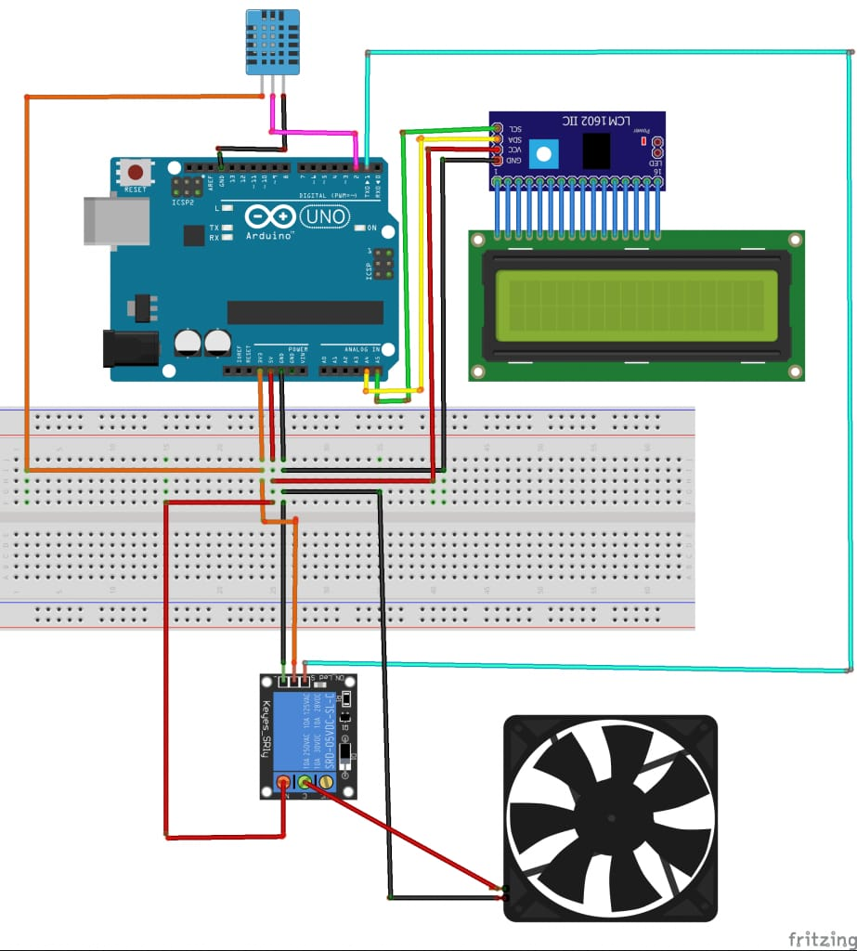

Fig .1

Components

1. Arduino: Arduino is an open-source electronics platform based on easy-to-use hardware and software. It consists of both a programmable circuit board (microcontroller) and an Integrated Development Environment (IDE) that runs on your computer, used to write and upload computer code to the physical board.

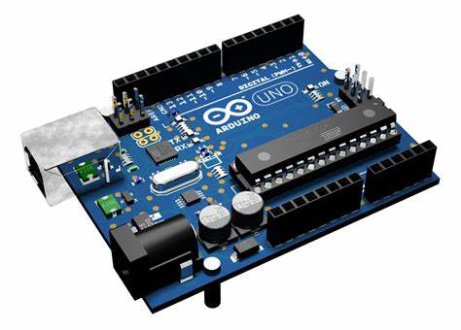

Fig.2

1. Humidity sensor: A humidity sensor, also known as a hygrometer, is a device that measures the amount of moisture in the air. These sensors are commonly used in a variety of applications, including weather monitoring, HVAC systems, industrial processes, and home automation.

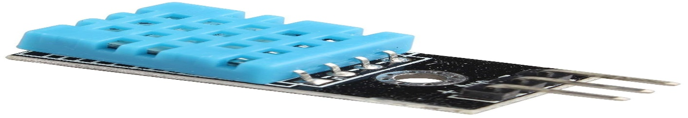

Fig.3

1. LCD Display: An LCD (Liquid Crystal Display) is a flat-panel display technology commonly used in screens for computers, televisions, and a variety of other electronic devices. LCDs use liquid crystals to produce images in color or monochrome.

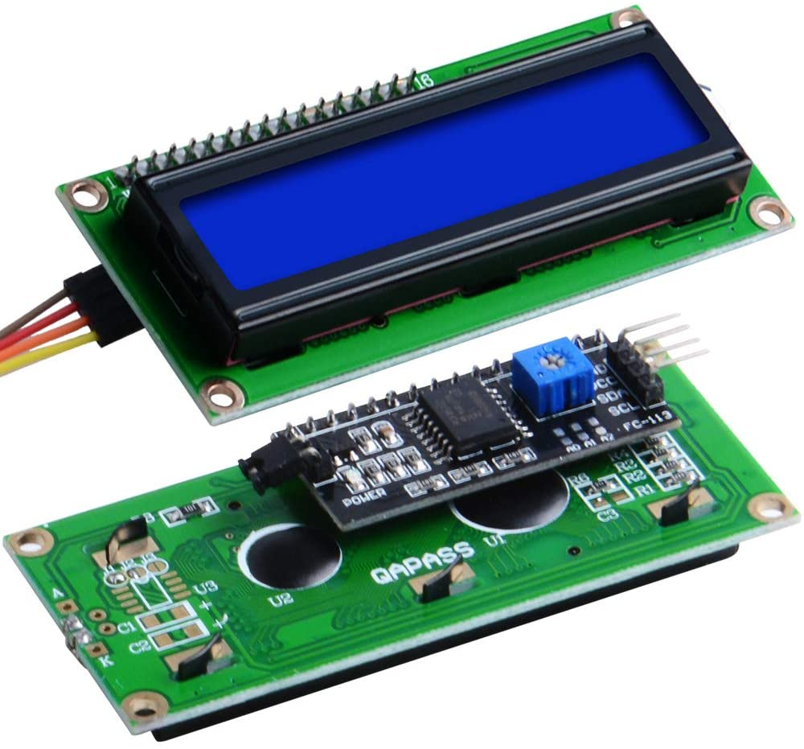

Fig.4

1. DC Fan: A DC fan is an electric fan powered by direct current (DC) electricity. These fans are widely used in various applications due to their efficiency, reliability, and ease of control.

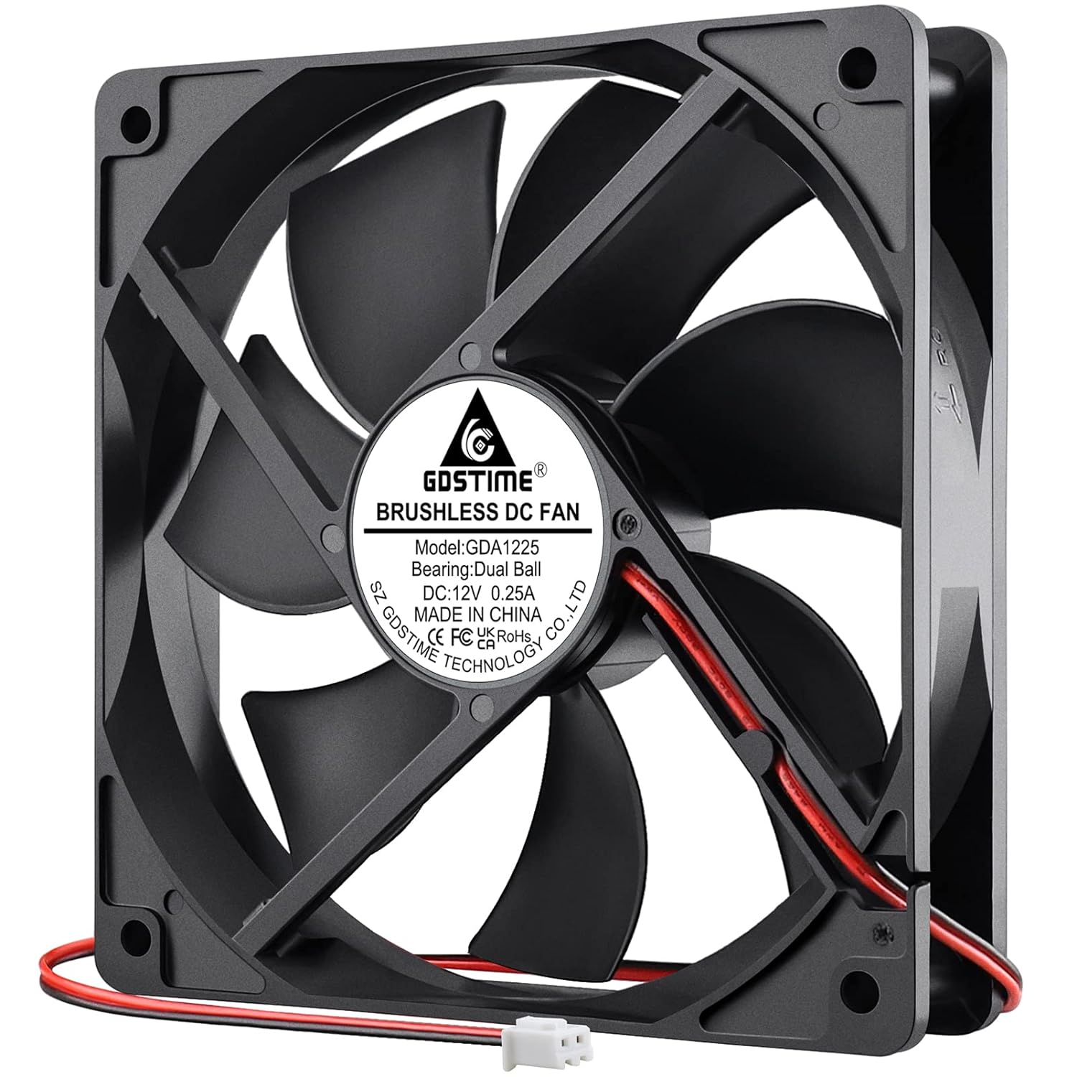

Fig .5

## WORKING PROCEDURE

* **Wind Capture:** The wind blows into the cups or propellers, causing them to spin. In a cup anemometer, typically three or four hemispherical cups are mounted on horizontal arms attached to a vertical shaft.

**Rotation:** The wind's force makes the cups or propellers spin around the vertical shaft. The of rotation is proportional to the wind speed.

* **Signal Generation:**

1. **Mechanical:** Some anemometers use mechanical methods to measure the rotations directly.
2. **Electrical:** In most modern anemometers, a magnetic or optical sensor is used. A magnet or reflective marker on the rotating shaft passes by a sensor each time the shaft makes a full rotation.
3. **Magnetic Sensor:** A magnet attached to the shaft passes by a stationary coil, generating a pulse each time it does.
4. **Optical Sensor:** An optical encoder or reflective surface on the shaft passes by a light beam, breaking it and generating a pulse

* **Signal Processing:** The sensor sends electrical pulses to a microcontroller or processing unit. The microcontroller counts the pulses over a fixed period and calculates the rotational speed.
* **Wind Speed Calculation:** The microcontroller uses the rotational speed to calculate the wind speed. The relationship between the rotational speed and wind speed is determined by the geometry of the anemometer and is usually established through calibration.
* **Display:** The calculated wind speed is then displayed on a screen or transmitted to a data logger or computer for further analysis.

**Code**

**#include <Wire.h>**

**#include <LiquidCrystal_I2C.h>**

**// Initialize the LCD with the I2C address**

**LiquidCrystal_I2C lcd(0x27, 16, 2);**

**const int anemometerPin = A0;**

**void setup() {**

**// Start the LCD**

**lcd.init();**

**lcd.backlight();**

**// Print a message to the LCD.**

**lcd.setCursor(0, 0);**

**lcd.print("Air Flow:");**

**// Initialize serial communication for debugging**

**Serial.begin(9600);**

**Serial.println("Setup completed");**

**}**

**void loop() {**

**// Read the analog value from the anemometer**

**int sensorValue = analogRead(anemometerPin);**

**// Convert the analog value to voltage (assuming 5V reference voltage)**

**float voltage = sensorValue * (5.0 / 1023.0)-0.42;**

**// Convert voltage to wind speed (example conversion, adjust as necessary)**

**float windSpeed = voltage * 10; // Example conversion factor**

**// Print the wind speed to the LCD**

**lcd.setCursor(0, 1);**

**lcd.print("Speed: ");**

**lcd.print(windSpeed);**

**lcd.print(" m/s "); // Added spaces to clear any previous longer values**

**// Print the wind speed to the serial monitor (for debugging)**

**Serial.print("Analog value: ");**

**Serial.print(sensorValue);**

**Serial.print(" -> Voltage: ");**

**Serial.print(voltage);**

**Serial.print("V -> Wind Speed: ");**

**Serial.print(windSpeed);**

**Serial.println(" m/s");**

**// Wait for a bit before taking another measurement**

**delay(1000);**

**}**

Result

Advantages

1. **Weather Forecasting:**
   * **Accurate Data Collection:** Provides precise measurements of wind speed, which are crucial for accurate weather forecasting.
   * **Early Warning Systems:** Helps in predicting severe weather conditions like hurricanes, storms, and tornadoes, thereby enabling early warnings and preventive measures.
2. **Safety:**
   * **Aviation and Marine Safety:** Critical for the safe operation of aircraft and ships by providing real-time wind speed data.
   * **Construction Sites:** Ensures safety in construction by monitoring wind conditions, which can affect cranes and other heavy machinery.
3. **Energy Production:**
   * **Wind Turbines:** Optimizes the placement and operation of wind turbines for efficient energy production.
   * **Solar Panels:** Assists in understanding wind patterns that may affect the efficiency of solar panel installations.
4. **Environmental Monitoring:**
   * **Pollution Dispersion Studies:** Helps in tracking and modeling the dispersion of pollutants in the atmosphere.
   * **Climate Research:** Provides data for studying climate change and understanding weather patterns over time.
5. **Agriculture:**
   * **Pesticide Application:** Assists farmers in determining the best times for applying pesticides, reducing waste and increasing efficiency.
   * **Irrigation:** Helps in planning irrigation by understanding evaporation rates influenced by wind speed.
6. **Recreational Activities:**
   * **Outdoor Sports:** Important for activities such as sailing, paragliding, and windsurfing where wind conditions are crucial.
   * **Tourism:** Enhances the safety and enjoyment of tourist activities that are dependent on weather conditions.

Disadvantges

1. **Calibration and Accuracy:**
   * **Calibration Requirements:** Anemometers require regular calibration to maintain accuracy. Over time, wear and tear can affect their performance.
   * **Accuracy Variations:** Different types of anemometers have varying accuracy levels. For example, cup anemometers may have errors in turbulent or gusty wind conditions.
2. **Environmental Sensitivity:**
   * **Weather Conditions:** Extreme weather conditions, such as heavy rain, snow, or ice, can affect the performance and accuracy of anemometers. Ice can particularly impact cup anemometers by adding weight and altering the rotational dynamics.
   * **Temperature Sensitivity:** Some anemometers, like hot-wire types, can be affected by temperature variations, leading to inaccuracies.
3. **Mechanical Wear and Maintenance:**
   * **Moving Parts:** Anemometers with moving parts (e.g., cup and vane anemometers) are subject to mechanical wear and tear. Bearings and other components may need regular maintenance or replacement.
   * **Dust and Debris:** Accumulation of dust, dirt, and debris can impair the functioning of the moving parts and sensors, requiring regular cleaning.
4. **Installation and Placement:**
   * **Proper Placement Needed:** Accurate wind measurement requires proper placement, often at specific heights and in open areas free from obstructions. Incorrect placement can lead to inaccurate readings.
   * **Installation Challenges:** Installing anemometers at the correct height and location, especially on tall masts or buildings, can be challenging and sometimes dangerous.
5. **Power Supply and Connectivity:**
   * **Power Requirements:** Some anemometers require a constant power supply, which can be a limitation in remote or off-grid locations.
   * **Data Transmission:** Ensuring reliable data transmission from remote anemometers to data collection centers can be challenging and may require robust communication systems.
6. **Cost:**
   * **High-End Models:** Advanced anemometers, such as ultrasonic or laser-based models, can be expensive, limiting their use to specific applications or organizations with sufficient budgets.

Applications

1. **Weather Monitoring and Forecasting:**

* **Meteorological Stations:** Used extensively in weather stations to monitor and record wind speed and direction, which are critical for weather forecasting and climate studies.
* **Storm Tracking:** Essential for tracking and predicting the path and intensity of storms, hurricanes, and other severe weather events.

1. **Aviation:**

* **Airport Operations:** Used to monitor wind conditions on runways and around airports to ensure safe takeoffs and landings.
* **Flight Planning:** Provides pilots with crucial information for flight planning and in-flight adjustments.

1. **Marine and Offshore:**

* **Navigation:** Used on ships and boats to aid in navigation and ensure safe operation in varying wind conditions.
* **Offshore Drilling:** Important for monitoring wind conditions on offshore platforms to ensure the safety of operations.

1. **Renewable Energy:**

* **Wind Turbine Sites:** Used to assess wind resources for the placement and operation of wind turbines, optimizing energy production.
* **Solar Farms:** Helps in evaluating wind conditions that can affect solar panel performance and maintenance.

1. **Construction and Engineering:**

* **Cranes and High-Rise Buildings:** Ensures the safety of cranes and construction sites, particularly at high elevations where wind speeds can be significantly higher.
* **Structural Analysis:** Used in the design and analysis of structures to ensure they can withstand wind loads.

1. **Environmental Monitoring:**

* **Air Quality Studies:** Helps in understanding the dispersion of pollutants in the atmosphere by measuring wind speed and direction.

1. **Agriculture:**

* **Pesticide Application:** Ensures safe and effective spraying of pesticides by monitoring wind conditions to prevent drift.
* **Crop Management:** Helps in understanding and managing the effects of wind on crops and soil erosion.

Conclusion

* Wind speed checkers, or anemometers, are essential instruments for measuring wind speed and direction, with applications ranging from meteorology and environmental monitoring to industrial processes and renewable energy. They come in various types, each with its specific advantages and disadvantages, including cup, vane, hot-wire, and ultrasonic anemometers.